Down Syndrome Association of San Diego

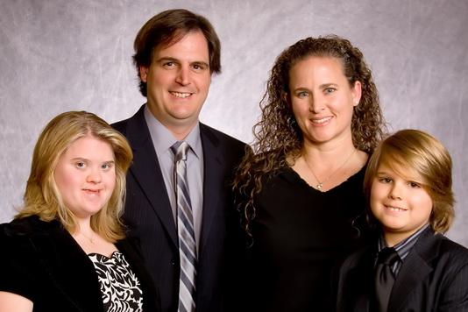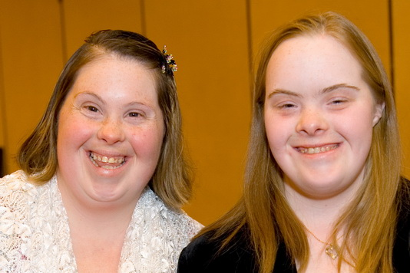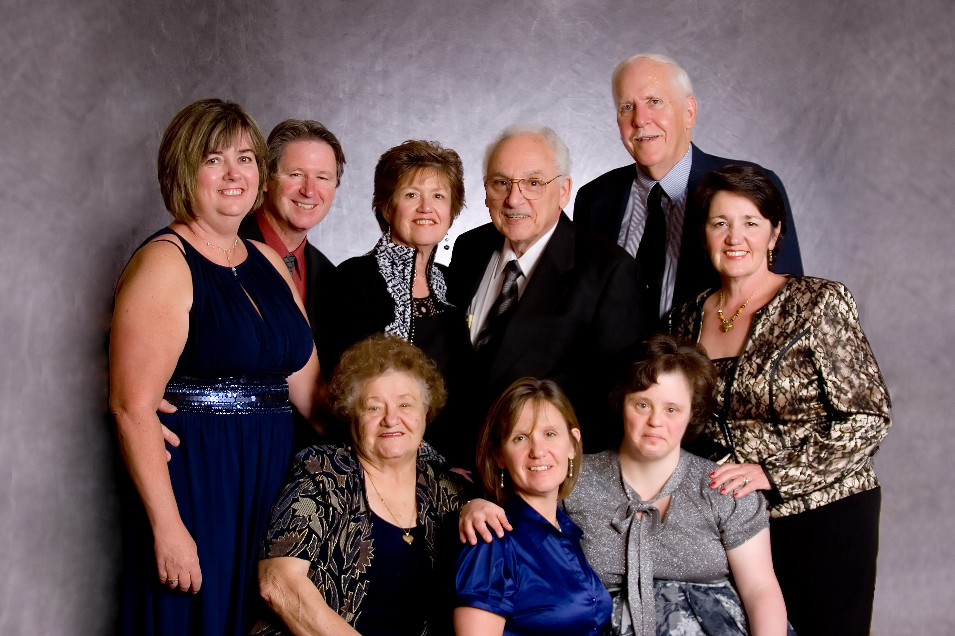
e-NEWS May 12, 2009

Dear Families and Friends,

The “Reach for the Stars Gala” was right out of this galaxy! Guests were greeted with a gift from *Diamond Boutique in Del Mar, an exquisite floating pearl necklace. Approximately 250 people danced the night and away to the sounds of Mobile Music Plus. The ballroom was spectacular with cascading towers of lilies and twinkling stars. Fine wine was served to guests compliments of Montesquieu Winery. Guests bid on spectacular vacations get-a-ways, jewelry, fine art, exotic theme baskets and more at the Silent Auction. *The Studios of Joseph Guidi* captured the night on film. Karen Gaffney delivered a moving keynote address, raising the bar and expectations for people with Down syndrome, and inspiring all of us to challenge ourselves to “Reach for the Stars.”

DSA President, Jackie Husson underscored the value of people with Down syndrome, the need to maintain high expectations with regard to their full potential and the importance of access to quality education, health care and research to ensure quality of life. Ms. Husson also highlighted the need for individuals, families, organizations and community to partner together to achieve common goals and meet the evolving needs of the Down syndrome community.

The Gala continues to grow each year creating new business and community partnerships. The success of the Gala is directly related to the participation and support from our members, their extended families, friends, business partners etc. Our individual personal and professional relationships are key to the growth and success of the Association. DSA will continue to improve expand the quality of services offered to families.

A resounding “THANK YOU” to all those who attended this year, especially during these economically challenging times. We hope to see you all next year...and please bring a friend or two! If you were unable to attend this year, we hope you will make every effort to attend next year.

Kindest regards
DSA Board of Directors

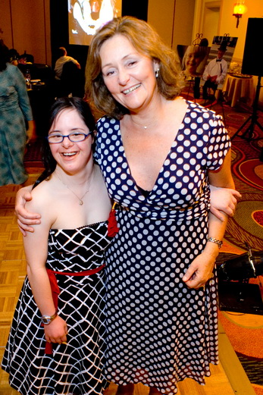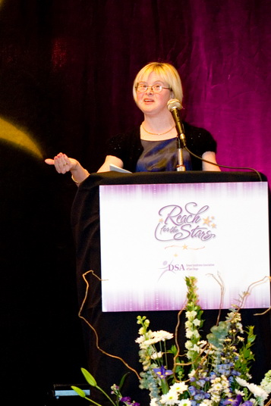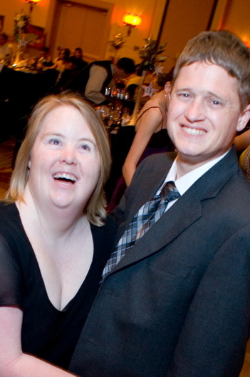

Congratulations to the DSA Star Award Recipients:
Kristie Jacobson, DSA Past President received an award for her Extraordinary Leadership and Community Service; Carlos Flores, Executive Director of the San Diego Regional Center accepted an award on behalf of the 480 staff, “Celebrating 40 years of Community Partnership;” and Tom Peters, Purchasing Manager for Montesquieu Winery received an award for his commitment to enhance the quality of life for people with Down Syndrome.

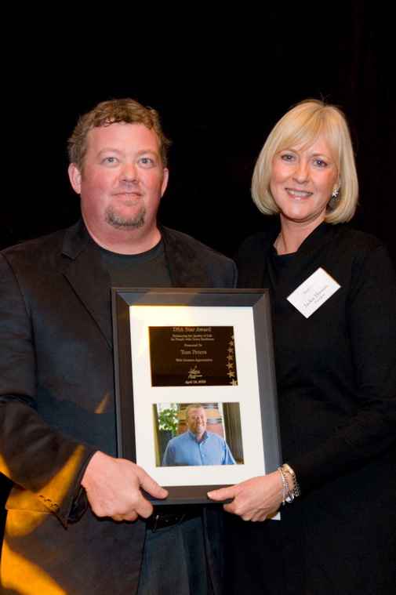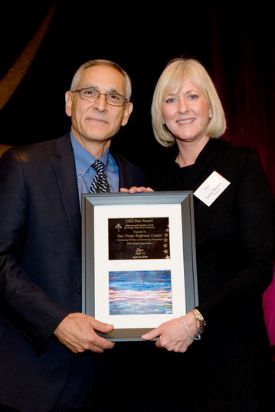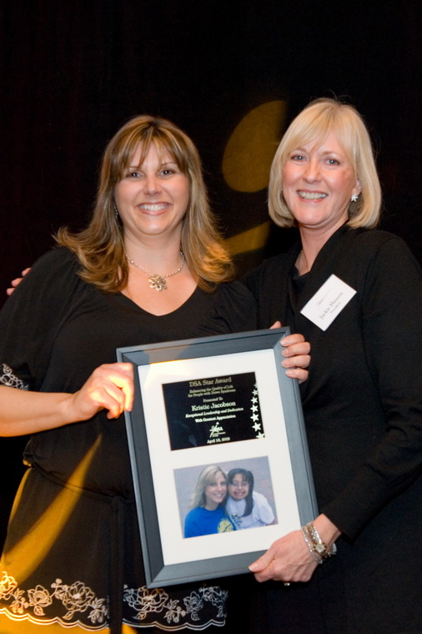
Tom Peters Carlos Flores Kristie Jacobson

As always, there are many individuals, families and businesses to thank and acknowledge. We are truly appreciative of the many donations we received and the overwhelming generosity of DSA families and their guests.

DSA Gold Star Table Supporters:
Baltins Family  Goldbaum Family  Husson Family | Vincent Family  Vattuone/Iraci Family

DSA Dinner Dance Committee:
Chairperson – Jackie Husson  Honorary Chairman – Mark Grant  Amy Baker  Kelly Baker – Barona Resort & Casino  Andy Baltins  Jill Bricnet  Mary Grant | Joseph Guidi  Julie Hodgetts  Rebecca McArthur  David Miller - Integrated Sports Marketing  Doreen O’Riley  Tom Peters - Montesquieu Winery  Stephen Vincent

DSA Donors:
A & A Mobile Detailing  Acacia Day Spa-Michelle Walk  Baker Family  Baltins Family  Barona Resort & Casino  Bricnet Family  Cabral Family  Clark Family  Crimson Speech & Language Center  David Bowers  Catherine & Art de los Rios  Diamond Boutique  Diamond Creations  Dreams Do Come True  Epilepsy Foundation – Brad Reylec  Exceptional Family Resource Center  Senator Dianne Feinstein  Four Seasons Flower Shop  John & Colleen Garbaczewski  Goldbaum Family  Great American Balloon Company  Grant Family  Guidi Films  H & M Landing  Lyn-Z Adams Hawkins  Hilton San Diego Resort & Spa  Hodgetts Family  Husson Family  Integrated Sports Marketing  David Miller  Iraci Family  JM Solutions – John Malthaner  John & Kay Krueger | Kidsville  Loews Coronado Bay Resort  Linda Lohmeyer  Medici Galleria  David Miller  Ken Miller & Liz Baxter  Montesquieu Winery – Tom Peters  Moore Family  Old Trieste Restaurant  Fred Oliver  Prowler Sportfishing  Pump It Up  Rancho La Puerta Resort & Spa  Raymond Peterson MD  Reynolds Family  Salcedo Family  San Diego Harbor Excursion  San Diego Marriott Mission Valley  San Miguel Firefighters  Scripps Hair & Skin Gallery  Jay, Griselle, Alexis  Shakespeare Pub & Grille  ShakeSpeare Corner Shoppe  Steele Canyon Golf Club  The Studios of Joseph Guidi  The Sunglass Shop  Tio Leo’s Mexican Restaurant  Vattuone Family  Viejas Enterprises  Vincent Family  Walmart El Cajon – Linda Stock  Wellman Family

*Diamond Boutique: Donations to Benefit the Down Syndrome Association
2710 Via De La Valle, B-280, Del Mar, CA 92014 (in the Flower Hill Promenade)
Phone: 858.720.1800 Website: www.diamondboutiqueonline.com
During the month of May, Diamond Boutique has generously offered to donate all proceeds from customers who purchase a battery change service to the Down Syndrome Association. Redeem your pearl necklace coupon and bring your watch for a battery change. Please be sure to let families and friends know about this opportunity benefiting DSA.

*The Studios of Joseph Guidi: Preview and order Reach for the Stars Gala Photos at http://www.imagequix.com/photog.php?id=P9M8G9K&ec=dsa
Photo Order Information:
4” x 6” - $7.50 / 5” x 7” - $12.50 / 8” x 10” - $25.00 / 11” x 14” - $45.00
2400 Kettner Blvd, Studio 208, San Diego, CA 92101 619.299.9799 josephguidi.com

*Proceeds beyond the actual costs will benefit the Down Syndrome Association.
----------------------------------------------------------------
DSA Family Support Network:


DSA School-Age Activity for May
Let’s Bowl
Sunday, May 17, 2009
1:00pm to 4:00pm
Marine Corp Recruit Depot/MCCS Recreation Center

Bowl . . . Play Video Games . . . or Just Hang
For Parents & Kids ages 5 – 15 years  Cost: $10/person and includes:  All activities plus pizza, dessert and drinks  Payable at Door (cash only) | 

Directions to MCRD:
From Pacific Hwy exit west to Barnett Avenue
Turn left/south onto Henderson Ave/Tuscaloosa St.
Gate #2/Guard house #613
Directions can be found at http://mcx-mcrdsandiego.com/directionstomcrd.htm
Once inside the gate, turn left at Belleau Wood
(the large square, low building with the archway).
Park at the south side of the building in the large parking lot.

Drivers must present a valid drivers license
and may be asked to submit proof of insurance at the gate

Please email your RSVP to smoore@projects.sdsu.edu
Include your name, phone, ages of children attending and number of accompanying adults
or call 619-594-7389

View Bowling flyer online at http://www.dsasdonline.org/admin/files/DSA%20School%20Age%20Bowling%20051709.doc



SAVE THE DATE
for our upcoming DSA Summer Social

Sunday, July 12, 2009
1:00pm to 4:00pm
De Anza Cove at Mission Bay Park
You will enjoy
Music ~ Dancing ~ Food ~ Prizes
Kids Activities and Play Area

> > > > SAVE THE DATE < < < <
Friday, June 12th will be Mom’s Night Out!
----------------------------------------------------------------
UPCOMING EVENTS:
For event details go to http://www.efrconline.org/calendar/maincal.cfm

There are several upcoming conferences that you might be interested in attending:

The “Tools for Educational Opportunities and Success” conference by DSA of Orange County will be held on May 15 and 16 at the Hilton in Costa Mesa. This conference will offer national and local presenters that will help you develop the tools you need to shape your child's education program into one full of opportunity and success. There will be something for every age and there are also self-advocate workshops on Saturday. Kathie Snow, author of Disability is Natural book, video, website, and newsletter is challenging the old ways of thinking, and helps parents, people with disabilities, and professionals acquire new perceptions and attitudes. www.dsaoc.org

The Involved Exceptional Parents’ Day Conference, which is packed full of great workshops, information and resources and offered at a very affordable cost, will be held on May 30th.

26th Annual
Involved Exceptional Parents’ Day Conference
Dream for Tomorrow, Plan for Today:
Practical Solutions for Tough Challenges
Congreso Annual #26
Día del Padre Involucrado Excepcional
Sueñe para Mañana, Planéelo Ahora:
Soluciones Prácticas a Situaciones Difíciles

Saturday May 30, 2009
Handlery Hotel * Mission Valley * San Diego, CA

$35 Parents / $40 Professionals
Keynote Speaker/Oradora Principal
Joan Medlen, R.D., L.D., M.Ed.
Forgiveness and Advocacy: An Effective Complement
Many times the best way to advocate is from a place of forgiveness.
Joan Medlen is the mother of two sons, one diagnosed with Down Syndrome, Celiac Disease and Autism. Ms. Medlen is a nutritionist, speaker, editor of Disability Solutions, and the author of the Down Syndrome Nutrition Handbook: A Guide to Promoting a Healthy Lifestyle.
Perdón y Abogacía: El Complemento Perfecto
Con frecuencia, el perdón es el mejor aliado de la abogacía.
Joan Medlen es madre de dos hijos, uno de ellos con sìndrome de Down, enfermedad celiaca y autismo. La Sra. Medlen is nutrióloga, oradora, editora de Disability Solutions (Soluciones para la discapacidad), y autora de Down Syndrome Nutrition Handbook: A Guide to Promoting a Healthy Lifestyle (Manual de Nutrición para el síndrome de Down: guía para promover una vida sana.)
REGISTER ONLINE AT iepday.org
858-576-2966 English / 858-576-2831 Español

----------------------------------------------------------------
UPCOMING DSA/EFRC SUPPORT GROUPS:
For details visit online calendar: http://www.efrconline.org/calendar/maincal.cfm

>>All May 2009 DSA/EFRC Support Groups have been canceled<<
Notice to the parents that attend the Down Syndrome Association support groups: Support groups are canceled during the month of May, as a precaution due to the recent concerns related to the swine flu virus (H1N1) outbreak. We hope to see you all in June! If you have any questions, please call the facilitator of your support group or you can call 619.594.7389. Thank you!

Comunicamos a los padres de familia que la Asociación de Síndrome de Down no facilitará grupos de apoyo durante el mes de mayo. Es una simple medida de precaución que tiene por objeto evitar una posible transmisión del virus de la influenza porcina entre las familias que asisten a los grupos. ¡Esperamos verlos de nuevo en junio! Para cualquier duda, por favor llame a las facilitadoras de su grupo de apoyo o llámenos sin costo al 619-594-7389. ¡Gracias!

5/12/09 Down Syndrome Support North – CANCELED/CANCELADO
5/21/09 Down syndrome Support Central SD - CANCELED/CANCELADO
2/28/09 Síndrome de Down Apoyo – CANCELED/CANCELADO

As an additional resource for you to Help Keep Kids Healthy: Handwashing songs, coloring books and posters in English and Spanish. http://www.henrythehand.com

----------------------------------------------------------------
OPPORTUNITIES:

Celebrate the 15th Anniversary of the Buddy Walk® by entering the Times Square Video Contest. The video, which showcases individuals with Down syndrome from all over the world, will air on a jumbo screen in the heart of Times Square on September 26, 2009 at 10:30 a.m. The New York City Buddy Walk will immediately follow the video presentation at the Great Hill in Central Park. Each year, NDSS receives thousands of photo submissions for the Times Square Video Contest. Because the Buddy Walk promotes acceptance and inclusion of individuals with Down syndrome, the winning photographs feature children, teens and adults with Down syndrome working, playing and learning with friends and family. July 15, 2009 is the deadline. Get More information. View the 2008 Times Square Video. For further questions contact Rebecca Switalski at timessquarevideo@ndss.org.

-----------------------------------------------------------------
RECREATION:

5/17/09 Xcite Steps Spring Fling from 11-1pm
Location: baseball field on the corner of Cedros Ave and Cliff Street in Solana Beach. There will be games, picnic style food and lots of people to meet other parents and children. The Spring Fling event is the kick off of Xcite Steps summer camp. This is the deadline for parents to sign their children up for this fun, original and fantastic summer camp. Xcite Steps Camp Dates will run from June 15th - August 28th. Feel free to stop by to meet the staff and parents at our Spring Fling Event! For more information, contact Matt Winkley at 858-722-1948 or visit excitesteps.com View Camp Steps brochure

5/31 Arts & Tea Celebration from 2:00-4:00pm
Celebrate Spring with Home of Guiding Hands at their 4th Annual Arts & Tea Celebration. Location: Ronald Reagan Community Center, 195 E. Douglas Ave in El Cajon. Enjoy a lovely array of traditional tea fare, mingle with friends, shop for one-of-a-kind works of art by local artisans, and have the chance to win door prizes, silent auction and participate in a host of opportunity drawings. Tickets to attend are $25 in advance, or $35.00 at the door. You may Purchase tickets online or call Marcy Blumberg at (619)938-2854.

----------------------------------------------
If you are experiencing difficulty reading this email because of your security settings, an electronic version of this eNEWS can be found online. If you enjoyed this eNEWS, please consider forwarding it to friends and family to spread the word of upcoming workshops and events, links to new sites and up-to-date information about Down syndrome. This e-NEWS has been brought to you by Down Syndrome Association of San Diego. If you have comments or would like to unsubscribe, please contact us at info@dsasdonline.org.
Down Syndrome Association of San Diego does not promote or recommend any therapy, treatment, institution, etc. and does not espouse any particular political, educational or religious views. Inclusion of information or resources does not necessarily imply promotion or recommendation by DSA. Content is provided for informational purposes only. www.DSAsdonline.org

Text version:
Down Syndrome Association of San Diego
e-NEWS
May 12, 2009

Dear Families and Friends,

The “Reach for the Stars Gala” was right out of this galaxy! Guests were greeted with a gift from *Diamond Boutique in Del Mar, an exquisite floating pearl necklace. Approximately 250 people danced the night and away to the sounds of Mobile Music Plus. The ballroom was spectacular with cascading towers of lilies and twinkling stars. Fine wine was served to guests compliments of Montesquieu Winery. Guests bid on spectacular vacations get-a-ways, jewelry, fine art, exotic theme baskets and more at the Silent Auction. *The Studios of Joseph Guidi* captured the night on film. Karen Gaffney delivered a moving keynote address, raising the bar and expectations for people with Down syndrome, and inspiring all of us to challenge ourselves to “Reach for the Stars.”

DSA President, Jackie Husson underscored the value of people with Down syndrome, the need to maintain high expectations with regard to their full potential and the importance of access to quality education, health care and research to ensure quality of life. Ms. Husson also highlighted the need for individuals, families, organizations and community to partner together to achieve common goals and meet the evolving needs of the Down syndrome community.

The Gala continues to grow each year creating new business and community partnerships. The success of the Gala is directly related to the participation and support from our members, their extended families, friends, business partners etc. Our individual personal and professional relationships are key to the growth and success of the Association. DSA will continue to improve expand the quality of services offered to families.

A resounding “THANK YOU” to all those who attended this year, especially during these economically challenging times. We hope to see you all next year...and please bring a friend or two! If you were unable to attend this year, we hope you will make every effort to attend next year.

Kindest regards
DSA Board of Directors

--------------------------------
Congratulations to the DSA Star Award Recipients:
Kristie Jacobson, DSA Past President received an award for her Extraordinary Leadership and Community Service; Carlos Flores, Executive Director of the San Diego Regional Center accepted an award on behalf of the 480 staff, “Celebrating 40 years of Community Partnership;” and Tom Peters, Purchasing Manager for Montesquieu Winery received an award for his commitment to enhance the quality of life for people with Down Syndrome.

As always, there are many individuals, families and businesses to thank and acknowledge. We are truly appreciative of the many donations we received and the overwhelming generosity of DSA families and their guests.

DSA Gold Star Table Supporters:
Baltins Family
Goldbaum Family
Husson Family
Vincent Family
Vattuone/Iraci Family

DSA Dinner Dance Committee:
Chairperson – Jackie Husson
Honorary Chairman – Mark Grant
Amy Baker
Kelly Baker – Barona Resort & Casino
Andy Baltins
Jill Bricnet
Mary Grant
Joseph Guidi
Julie Hodgetts
Rebecca McArthur
David Miller - Integrated Sports Marketing
Doreen O’Riley
Tom Peters - Montesquieu Winery
Stephen Vincent

DSA Donors:
A & A Mobile Detailing
Acacia Day Spa-Michelle Walk
Baker Family
Baltins Family
Barona Resort & Casino
Bricnet Family
Cabral Family
Clark Family
Crimson Speech & Language Center
David Bowers
Catherine & Art de los Rios
Diamond Boutique
Diamond Creations
Dreams Do Come True
Epilepsy Foundation – Brad Reylec
Exceptional Family Resource Center
Senator Dianne Feinstein
Four Seasons Flower Shop
John & Colleen Garbaczewski
Goldbaum Family
Great American Balloon Company
Grant Family
Guidi Films
H & M Landing
Lyn-Z Adams Hawkins
Hilton San Diego Resort & Spa
Hodgetts Family
Husson Family
Integrated Sports Marketing
David Miller
Iraci Family
JM Solutions – John Malthaner
John & Kay Krueger
Kidsville
Loews Coronado Bay Resort
Linda Lohmeyer
Medici Galleria
David Miller
Ken Miller & Liz Baxter
Montesquieu Winery – Tom Peters
Moore Family
Old Trieste Restaurant
Fred Oliver
Prowler Sportfishing
Pump It Up
Rancho La Puerta Resort & Spa
Raymond Peterson MD
Reynolds Family
Salcedo Family
San Diego Harbor Excursion
San Diego Marriott Mission Valley
San Miguel Firefighters
Scripps Hair & Skin Gallery
Jay, Griselle, Alexis
Shakespeare Pub & Grille
ShakeSpeare Corner Shoppe
Steele Canyon Golf Club
The Studios of Joseph Guidi
The Sunglass Shop
Tio Leo’s Mexican Restaurant
Vattuone Family
Viejas Enterprises
Vincent Family
Walmart El Cajon – Linda Stock
Wellman Family
----------------------------------------------------------------
*The Studios of Joseph Guidi: Preview and order Reach for the Stars Gala Photos at http://www.imagequix.com/photog.php?id=P9M8G9K&ec=dsa
Photo Order Information:
4” x 6” - $7.50 / 5” x 7” - $12.50 / 8” x 10” - $25.00 / 11” x 14” - $45.00
2400 Kettner Blvd, Studio 208, San Diego, CA 92101 619.299.9799 josephguidi.com

*Proceeds beyond the actual costs will benefit the Down Syndrome Association.
----------------------------------------------------------------
DSA Family Support Network:

DSA School-Age Activity for May
Let’s Bowl
Sunday, May 17, 2009
1:00pm to 4:00pm
Marine Corp Recruit Depot/MCCS Recreation Center

Bowl . . . Play Video Games . . . or Just Hang
For Parents & Kids ages 5 – 15 years
Cost: $10/person and includes:
All activities plus pizza, dessert and drinks
Payable at Door (cash only)

Directions to MCRD:
From Pacific Hwy exit west to Barnett Avenue
Turn left/south onto Henderson Ave/Tuscaloosa St.
Gate #2/Guard house #613
Directions can be found at http://mcx-mcrdsandiego.com/directionstomcrd.htm
Once inside the gate, turn left at Belleau Wood
(the large square, low building with the archway).
Park at the south side of the building in the large parking lot.

Drivers must present a valid drivers license
and may be asked to submit proof of insurance at the gate

Please email your RSVP to smoore@projects.sdsu.edu
Include your name, phone, ages of children attending and number of accompanying adults
or call 619-594-7389

View Bowling flyer online at http://www.dsasdonline.org/admin/files/DSA%20School%20Age%20Bowling%20051709.doc

SAVE THE DATE
for our upcoming DSA Summer Social
Sunday, July 12, 2009
1:00pm to 4:00pm
De Anza Cove at Mission Bay Park
You will enjoy
Music ~ Dancing ~ Food ~ Prizes
Kids Activities and Play Area

----------------------------------------------------------------
UPCOMING EVENTS:
For event details go to http://www.efrconline.org/calendar/maincal.cfm

There are several upcoming conferences that you might be interested in attending:

The “Tools for Educational Opportunities and Success” conference by DSA of Orange County will be held on May 15 and 16 at the Hilton in Costa Mesa. This conference will offer national and local presenters that will help you develop the tools you need to shape your child's education program into one full of opportunity and success. There will be something for every age and there are also self-advocate workshops on Saturday. Kathie Snow, author of Disability is Natural book, video, website, and newsletter is challenging the old ways of thinking, and helps parents, people with disabilities, and professionals acquire new perceptions and attitudes. www.dsaoc.org

The Involved Exceptional Parents’ Day Conference, which is packed full of great workshops, information and resources and offered at a very affordable cost, will be held on May 30th.

26th Annual
Involved Exceptional Parents’ Day Conference
Dream for Tomorrow, Plan for Today:
Practical Solutions for Tough Challenges
Congreso Annual #26
Día del Padre Involucrado Excepcional
Sueñe para Mañana, Planéelo Ahora:
Soluciones Prácticas a Situaciones Difíciles

Saturday May 30, 2009
Handlery Hotel * Mission Valley * San Diego, CA

$35 Parents / $40 Professionals
Keynote Speaker/Oradora Principal
Joan Medlen, R.D., L.D., M.Ed.
Forgiveness and Advocacy: An Effective Complement
Many times the best way to advocate is from a place of forgiveness.
Joan Medlen is the mother of two sons, one diagnosed with Down Syndrome, Celiac Disease and Autism. Ms. Medlen is a nutritionist, speaker, editor of Disability Solutions, and the author of the Down Syndrome Nutrition Handbook: A Guide to Promoting a Healthy Lifestyle.
Perdón y Abogacía: El Complemento Perfecto
Con frecuencia, el perdón es el mejor aliado de la abogacía.
Joan Medlen es madre de dos hijos, uno de ellos con sìndrome de Down, enfermedad celiaca y autismo. La Sra. Medlen is nutrióloga, oradora, editora de Disability Solutions (Soluciones para la discapacidad), y autora de Down Syndrome Nutrition Handbook: A Guide to Promoting a Healthy Lifestyle (Manual de Nutrición para el síndrome de Down: guía para promover una vida sana.)
REGISTER ONLINE AT iepday.org
858-576-2966 English / 858-576-2831 Español

----------------------------------------------------------------
UPCOMING DSA/EFRC SUPPORT GROUPS:
For details visit online calendar: http://www.efrconline.org/calendar/maincal.cfm

>>All May 2009 DSA/EFRC Support Groups have been cancelled<<
Notice to the parents that attend the Down Syndrome Association support groups: Support groups are cancelled during the month of May, as a precaution due to the recent concerns related to the swine flu virus (H1N1) outbreak. We hope to see you all in June! If you have any questions, please call the facilitator of your support group or you can call 619.594.7389. Thank you!

Comunicamos a los padres de familia que la Asociación de Síndrome de Down no facilitará grupos de apoyo durante el mes de mayo. Es una simple medida de precaución que tiene por objeto evitar una posible transmisión del virus de la influenza porcina entre las familias que asisten a los grupos. ¡Esperamos verlos de nuevo en junio! Para cualquier duda, por favor llame a las facilitadoras de su grupo de apoyo o llámenos sin costo al 619-594-7389. ¡Gracias!

5/12/09 Down Syndrome Support North – CANCELED/CANCELADO
5/21/09 Down syndrome Support Central SD - CANCELED/CANCELADO
2/28/09 Síndrome de Down Apoyo – CANCELED/CANCELADO

As an additional resource for you to Help Keep Kids Healthy: Handwashing songs, coloring books and posters in English and Spanish. http://www.henrythehand.com

----------------------------------------------------------------
OPPORTUNITIES:

Celebrate the 15th Anniversary of the Buddy Walk® by entering the Times Square Video Contest. The video, which showcases individuals with Down syndrome from all over the world, will air on a jumbo screen in the heart of Times Square on September 26, 2009 at 10:30 a.m. The New York City Buddy Walk will immediately follow the video presentation at the Great Hill in Central Park. Each year, NDSS receives thousands of photo submissions for the Times Square Video Contest. Because the Buddy Walk promotes acceptance and inclusion of individuals with Down syndrome, the winning photographs feature children, teens and adults with Down syndrome working, playing and learning with friends and family. July 15, 2009 is the deadline. Get More information. View the 2008 Times Square Video. For further questions contact Rebecca Switalski at timessquarevideo@ndss.org.

-----------------------------------------------------------------
RECREATION:

5/17/09 Xcite Steps Spring Fling from 11-1pm
Location: baseball field on the corner of Cedros Ave and Cliff Street in Solana Beach. There will be games, picnic style food and lots of people to meet other parents and children. The Spring Fling event is the kick off of Xcite Steps summer camp. This is the deadline for parents to sign their children up for this fun, original and fantastic summer camp. Xcite Steps Camp Dates will run from June 15th - August 28th. Feel free to stop by to meet the staff and parents at our Spring Fling Event! For more information, contact Matt Winkley at 858-722-1948 or visit excitesteps.com View Camp Steps brochure at http://www.efrconline.org/admin/files/Xcite%20steps%20summer%20camp%202009.pdf

5/31 Arts & Tea Celebration from 2:00-4:00pm
Celebrate Spring with Home of Guiding Hands at their 4th Annual Arts & Tea Celebration. Location: Ronald Reagan Community Center, 195 E. Douglas Ave in El Cajon. Enjoy a lovely array of traditional tea fare, mingle with friends, shop for one-of-a-kind works of art by local artisans, and have the chance to win door prizes, silent auction and participate in a host of opportunity drawings. Tickets to attend are $25 in advance, or $35.00 at the door. You may Purchase tickets online or call Marcy Blumberg at (619)938-2854.

----------------------------------------------
If you are experiencing difficulty reading this email because of your security settings, an electronic version of this eNEWS can be found online. If you enjoyed this eNEWS, please consider forwarding it to friends and family to spread the word of upcoming workshops and events, links to new sites and up-to-date information about Down syndrome. http://www.dsasdonline.org/dsasd.cfm?pid=listserve_form

This e-NEWS has been brought to you by Down Syndrome Association of San Diego. If you have comments or would like to unsubscribe, please contact us at info@dsasdonline.org. Down Syndrome Association of San Diego does not promote or recommend any therapy, treatment, institution, etc. and does not espouse any particular political, educational or religious views. Inclusion of information or resources does not necessarily imply promotion or recommendation by DSA. Content is provided for informational purposes only. www.DSAsdonline.org

